**Experiment 2.**

* **Aim:** Design an LED Chaser
* **Circuit Diagram:**

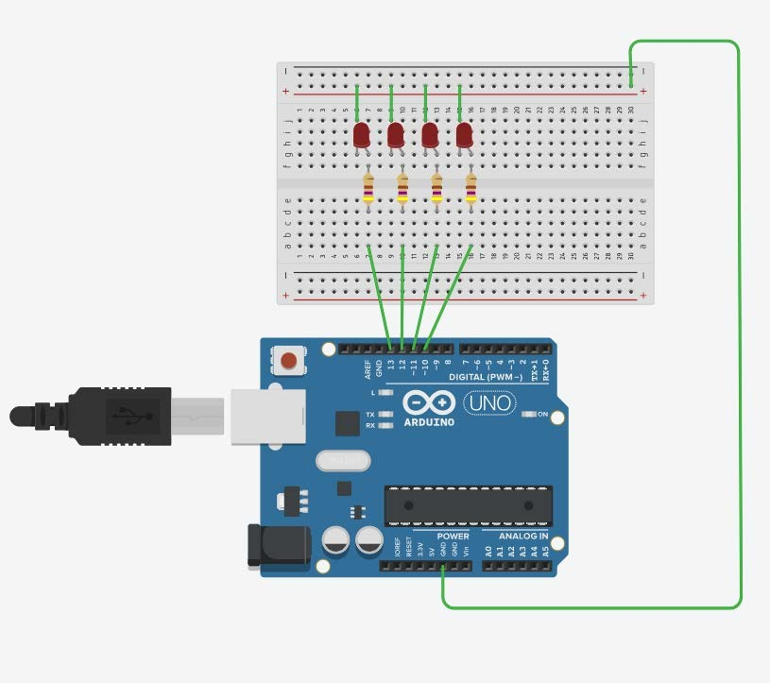

$Theory:$

* The chaser or sequencer is one of the most popular types of LED-driving circuit and is widely used in advertising displays and in running-light ‘rope’ displays in small discos, etc.
* It consists of a clocked IC or other electronic unit that drives an array of LEDs in such a way that individual LEDs (or small groups of LEDs) turn on and off in a predetermined and repeating sequence, thus producing a visually attractive display in which one or more ripples of light seem to repeatedly run through a chain or around a ring of LEDs.
* In this experiment we will make the LED chaser using Arduino.
* **Problems & Troubleshooting:**

*Problems:*

1. One of the LED was not Glowing at all.
2. Arduino had some issue while connecting it with the computer.

*Troubleshooting*

1. Replacing the LED with another one.
2. The port selection on the computer was done again and the driver was reinstalled.

* **Precautions:**

1. When dealing with extremely small components such as LED, Resistors or switches one must take care that they are not broken or lost while connecting on the breadboard.
2. The LED should not be connected in a reverse manner or else it won’t work.
3. The connections should be tight and proper.
4. The code must be prepared in a way so that it solves the purpose.

* **Learning Outcomes:**

From this Experiment of LED Flasher, I have learnt:

1. Working of multi-meter.
2. The connections on a breadboard.
3. The working of an Arduino.
4. The coding and error resolving for Arduino.
5. The fundamentals of electricity.
6. The use of resistor.
7. The sequential coding for LED’s to blink on demand.
8. Different pin-modes in a Arduino.